**BIJLI - THE E-CYCLE**

A MINI PROJECT REPORT

**SUBMITTED BY**

**ARUN KUMAR.R 211420105011**

**GOKULA KRISHNAN.P 211420105026**

**ARAVINDHA KRISHNAN .G 211420105007**

**in partial fulfilment for the award of the degree**

**of**

**BACHELOR OF ENGINEERING**

**IN**

**ELECTRICAL AND ELECTRONICS ENGINEERING**



**PANIMALAR ENGINEERING COLLEGE**

**(An Autonomous Institution)**

**Affiliated to Anna University ,Chennai-600123**

# APRIL 2023

# PANIMALAR ENGINEERING COLLEGE

# (An Autonomous Institution)

# Affiliated to Anna University, Chennai

# BONAFIDE CERTIFICATE

Certified that this project report **“ BIJLI – THE E-CYCLE ”** is the bonafide work of **“ ARUNKUMAR (211420105011), GOKULAKRISHNAN (211420105026), ARAVINDHAKRISHNAN (2114201051007), ”** who carried out the project work under my supervision

|  |  |
| --- | --- |
| **SIGNATURE** | **SIGNATURE** |
| **Dr. S.SELVI, M.E ,Ph.D.** | **MR.PONKUMAR M.E.,( PhD)**  **ASST PROFESSOR** |
| **HEAD OF THE DEPARTMENT** | **SUPERVISOR** |
| **PROFESSOR** | **PROFESSOR** |
| Department of Electrical and | Department of Electrical and |
| Electronics Engineering, | Electronics Engineering, |
| Panimalar Engineering College, | Panimalar Engineering College, |
| Chennai- 600 123 | Chennai- 600 123 |

Submitted for VI Semester Project Viva Voce held on at

Panimalar Engineering College, Chennai

INTERNAL EXAMINER EXTERNAL EXAMINER

**ACKNOWLEDGEMENT**

Our sincere thanks to our Honorable Founder and Chairman, Dr.JEPPIAAR, M.A., B.L., Ph.D., for his sincere endeavor in educating us in his premier institution.

We would like to express our deep gratitude to our beloved Secretary and correspondent, Dr. P. CHINNADURAI, M.A., M.Phil., Ph.D., for his enthusiastic motivation which inspired us a lot in completing this project and our sincere thanks to our Directors Mrs. C. VIJAYA RAJESWARI, Dr. C. SHAKTHI KUMAR, M.E., Ph.D., AND Dr. SARANYASREE SAKTHI KUMAR, B.E., M.B.A., Ph.D., for providing us with necessary facilities for the completion of this project.

We would like to express thanks to our Principal, Dr. K. MANI, M.E., Ph.D., for extended his guidance and cooperation.

We would also like to thank our Head of the Department, Dr. S. SELVI, M.E., Ph.D., Professor and Head, Department of Electrical and

Personally, we thank our guide Mr. PONKUMAR, M.E.,( Ph.D.,) Assistant Professor, in Department of Electrical and Electronics Engineering for the persistent motivation and support for this project, who at all times was the mentor of germination of this project from a small idea.

We express our sincere thanks to the project coordinators Dr. S. DEEPA M.E., Ph.D., & Dr. N. MANOJ KUMAR, M.E., Ph.D., in Department

Of Electrical and Electronics Engineering for the valuable Suggestions from time to time at every stage of our project.

Finally, we would like to take this opportunity to thank our family members, faculty and non-teaching staff members of our department, friends, well-wishers who have helped us for the successful completion of our project.

**ABSTRACT**

Nowadays, ELECTRIC CYCLE is common in our life but we have difficulties for the power source and storage of power in batteries. In olden days we have used a dynamo For generating power , but its only used for lighting loads. to over come it , we have Implemented an old idea in a new manner. Now in latest model electric cycles there is a permanent magnet brushless dc motor in hub type which drives the electric cycle by consuming power from batteries .by the time goes the efficiency of the electric cycle is increased when compared to existing previous models.

In addition to this advancement we have planned to improve the efficiency further by implementing the concept of power generation in electric cycle .In our concept by analyzing we have designed an alternator using permanent magnet and mounted on the front wheel, in turn the hub motor is mounted on the rear wheel. When the hub motor drives the electric cycle automatically the front wheel also rotates. the alternator in turns converts the rotational force (Mechanical energy)into electrical energy. The generated energy is stored in the battery for the later use thereby increasing the mileage of the electric cycle. Our concept is not only suitable for electric cycles, its also suitable for any mode of electric vehicles.

**TABLE OF CONTENTS**

|  |  |  |
| --- | --- | --- |
| **CHAPTER NO** | **TITLE** | **PAGE NO** |
|  | ABSTRACT | 4 |
|  | LIST OF FIGURES | 7 |
|  | LIST OF ABBREVIATIONS | 8 |
|  |  |  |
| **1** | **ARCHITECTURE OF ELECTRIC VEHICLE** | **9** |
|  | 1.1 INTRODUCTION | 9 |
|  | 1.2 ARCHITECTURE | 10 |
|  | 1.3 IMPORTANCE OF EV ARCHITECTURE | 10 |
|  | 1.4 PARTS OF E-CYCLE | 11 |
|  | 1.4.1 Motor | 11 |
|  | 1.4.2 Controller | 12 |
|  | 1.4.3 Li-Ion Battery | 12 |
|  | 1.4.4 Braking System | 13 |
|  | 1.4.5 Throttle | 13 |
|  | 1.4.6 Horn And Light | 13 |
|  | 1.4.7 Pedal Assistance Sensor | 13 |
|  | 1.4.8 Alternator | 14 |
|  | 1.4.9 Controller For Alternator | 14 |
|  | 1.4.10 Charging Module | 14 |
| **2** | **PERFORMANCE AND ANALYSIS OF MOTOR** | **15** |
|  | 2.1 INTRODUCTION | 15 |
|  | 2.2 LAYOUT OF PMBLDC MOTOR | 16 |
|  | 2.3 CONSTRUCTION OF PMBLDC MOTOR | 17 |
|  | 2.4 TYPES OF BLDC MOTOR | 18 |
|  | 2.5 SIMULATION OF BLDC MOTOR | 19 |
|  | 2.6 POSITION SENSOR | 22 |
|  | 2.7 WORKING PRINCIPLE OF PMBLDC MOTOR | 22 |
|  | 2.8 ADVANTAGE& DISADVANTAGE OF PMBLDC | 22 |
|  | 2.9 APPLICATIONS OF PMBLDC MOTOR | 25 |
| **3** | **ANALYSIS OF MOTOR CONTROLLER** | **26** |
|  | 3.1 INTRODUCTION | 26 |
|  | 3.2 BLOCK DIAGRAM OF CONTROLLER | 27 |
|  | 3.3 ESC | 27 |
|  | 3.4 TYPES OF MOTOR CONTROLLER | 28 |
|  | 3.5 APLLICATIONS OF MOTOR CONTROLLER | 28 |
| **4** | **DESIGN OF BATTERY PACKAGE AND MANAGEMENT SYSTEM** | **30** |
|  | 4.1 INTRODUCTION | 30 |
|  | 4.2 TYPES OF BATTERY | 30 |
|  | 4.3 LITHIUM ION BATTERY | 31 |
|  | 4.4 WORKING OF LITHIUM ION BATTERY | 32 |
|  | 4.5 CHARGING& DISCHARGING | 34 |
|  | 4.6 ADVANTAGES OF LI-ION BATTERY | 35 |
|  | 4.7 LIMITATIONS OF LI-ION BATTERY | 36 |
|  | 4.8 APPLICATIONS OF LI-ION BATTERY | 36 |
| **5** | **ANALYSIS OF BATTERY MANAGEMENT SYSTEM** | **37** |
|  | 5.1 INTRODUCTION | 37 |
|  | 5.2 TYPES OF BMS | 37 |
|  | 5.3 WORKING OF BMS | 37 |
|  | 5.4 ADVANTAGES& DISADVANTAGES OF BMS | 38 |
| **6** | **PEDAL ASSISTANCE SENSOR** | **39** |
|  | 6.1 INTRODUCTION | 39 |
|  | 6.2 TYPES OF PEDAL ASSISTANCE SENSOR | 40 |
|  | 6.3 WORKING OF PEDAL ASSISTANCE SENSOR | 40 |
|  | 6.4 ADVANTAGES | 41 |
| **7** | **ANALYSIS OF ALTERNATOR** | **42** |
|  | 7.1 INTRODUCTIN | 42 |
|  | 7.2 CONSTRUCTION OF AN ALTERNATOR | 43 |
|  | 7.3 WORKING | 43 |
|  | 7.4 CHARACTERISTICS | 43 |
|  | 7.5 APPLICATION | 44 |
|  | 7.6 ADVANTAGES | 44 |
|  | 7.7 DISADVANTAGES | 44 |
|  | 7.8 ANALYSIS OF ALTERNATOR CONTROLLER | 45 |
|  | 7.8.1 Rectifying Unit | 45 |
|  | 7.8.2 Converter Unit | 45 |
|  | 7.8.3 Regulator Unit | 45 |
| **8** | **ADDITIONAL FEATURES IN BIJLI E-CYCLE** | **47** |
|  | 8.1 ELECTICAL AND MECHANICAL BRAKING | 47 |
|  | 8.2 THROTTLE WITH BATTERY DISPLAY | 48 |
|  | 8.3 HORN ATTACHED WITH LIGHT | 49 |
|  | 8.4 DISPLAYS | 49 |
| **9** | **OUTCOMES & RESULTS OF BIJLI THE E-CYCLE** | **51** |
|  | 9.1 SYSTEM OUTPUT | **51** |
|  | 9.2 LIMITATIONS | **54** |
|  | 9.3 FUTURE SCOPE | **54** |
|  |  |  |
|  | **CONCLUSION** | **55** |
|  |  |  |
|  | **REFERENCE** | **57** |

**LIST OF FIGURES**

|  |  |  |
| --- | --- | --- |
| **FIGURE NO.** | **TITTLE** | **PAGE NO.** |
|  |  |  |
| 1.1 | ARCHITECTURE OF EV | 11 |
|  |  |  |
| 2.1 | HUB MOTOR | 18 |
| 2.2 | PMBLDC MOTOR LAYOUT | 16 |
| 2.3 | CONSTRUCTIN OF BLDC | 17 |
| 2.4 | BLDC MOTOR | 18 |
| 2.5 | INNER ROTOR DESIGN OF BLDC | 18 |
| 2.6 | OUTER ROTOR DESIGN OF BLDC | 19 |
| 2.7 | SIMULATION OF BLDC MOTOR | 19 |
| 2.8 | RESULT AT CONSTANT CONDITION | 20 |
| 2.9 | RESULT AT VARIABLE CONDITION | 21 |
| 2.10 | SWITCHING SEQUENCE OF BLDC MOTOR | 23 |
|  |  |  |
| 3.1 | CONTROLLER | 26 |
| 3.2 | BLOCK DIAGRAM OF CONTROLLER | 27 |
| 3.3 | BLOCK DIAGAM OF ESC | 28 |
|  |  |  |
| 4.1 | LITHIUM-ION BATTERY | 31 |
| 4.2 | CHARGING OF LI-ION CELL | 33 |
| 4.3 | DISCHARGE OF LI-ION CELL | 33 |
| 4.4 | LITHIUM ION CHARGER | 34 |
|  |  |  |
| 6.1 | PEDAL ASSISTANCE SENSOR | 39 |
|  |  |  |
| 7.1 | HUB TYPE ALTERNATOR | 42 |
| 7.2 | CONTROLLER CIRCUIT FOR ALTERNATOR | 45 |
| 7.3 | THREE PHASE RECTIFIER | 46 |
|  |  |  |
| 8.1 | ELECTRICAL AND MECHANICAL BRAKE | 47 |
| 8.2 | THROTTLE WITH BATTERY INDICATOR | 48 |
| 8.3 | HORN ATTACHED WITH LIGHT | 49 |
| 8.4 | DISPLAY | 49 |
|  |  |  |
| 9.1 | BIJLI – E-CYCLE | 53 |
| 9.2 | TOP VIEW OF E-CYCLE | 53 |

**LIST OF ABBREVIATION**

|  |  |
| --- | --- |
| E-CYCLE | Electric Cycle |
| EV | Electric Vehicle |
| DC | Direct Current |
| AC | Alternating Current |
| KW | Kilowatt |
| KWH | Kilowatt/Hour |
| V | Voltage |
| A | Amps |
| W | Watts |
| AH | Ampere Hour |
| PM | Permanent Magnet |
| BLDC | Brushless Direct Current |
| LI-ION BATTERY | Lithium Ion Battery |
| LIFEPO4 | Lithium Ferro Phosphate |
| BMS | Battery Management System |
| ESC | Electronic Speed Controller |
| DCFC | Direct Current Fast Charger |

**CHAPTER 1**

**ARCHITECTURE OF ELECTRIC VEHICLE**

**1.1 INTRODUCTION:**

Electric power is the primary energy source of electrical vehicles (EVs). The key benefit is the electric motor's proposal system's great efficiency in power conversion. Large-scale research and development projects have recently been reported in both academia and business. There are also commercial vehicles available. Many nations offer incentives to users in the form of reduced tax rates or tax exemptions, free parking spaces, and free charging stations.

This paper is to examine the new concept in EVs using E-Cycle as working model. Electric vehicles (EVs) use electricity as their primary fuel or to improve the efficiency of conventional vehicle designs. EVs include all vehicles, also referred to Electric cycle, Electric Bike, Electric scooty, Electric cars, Electric Buses, and all other mode of transports.

In most recent models of electric cycles have permanent magnet brushless dc motors in hub configurations that use battery power to drive the electric cycle. As time passes, the electric cycle's efficiency rises in comparison to earlier types that were in use. Along with this development, we have plans to increase efficiency even more by including the idea of power generation in an electric cycle. The hub motor is mounted on the rear wheel, and the alternator, which we created using a permanent magnet, is mounted on the front wheel in our concept. The front wheel rotates in tandem with the hub motor's automated electric cycle drive. The rotating force (mechanical energy) is converted into electrical energy by the alternator. The energy produced is stored in the battery for later use, enhancing the electric cycle's range. Our idea can be used for any type of electric vehicle, not just electric bicycles.

* 1. **ARCHITECTURE :**

The phrase "electrical/electronic architecture" refers to the integration of electronics hardware, network communications, software applications, and wiring into a single, integrated system that manages an ever-increasing range of vehicle functions, including active safety, comfort, convenience, and connectivity features as well as body and security, infotainment, and vehicle control.

* 1. **IMPORTANCE OF EV ARCHITECTURE:**

The chosen architecture is crucial because it provides an understanding of the whole cycle of operation, requires that components be arranged in a certain order, and helps designers balance performance and cost. Due to its fundamental character, an electrical architecture enables the smooth integration of several cutting-edge technologies. This necessitates particular consideration while creating and implementing an architecture that meets today's needs while enabling the design to address difficulties in the future. Future EA will make it possible for cars to operate more quickly and react to infrastructure that is more linked and intelligent. EVs are operated by an EA as two-way power flow systems that communicate with a smart grid and a networked infrastructure. EV platforms of today are advancing towards multisensor and autonomous driving technologies. The electric vehicle architecture must communicate, act, and control more quickly to achieve the desired results. The EA will play a crucial part in this trip by cooperating, safeguarding, self-learning, self-healing, and linking to each ECU and to the master VCU..

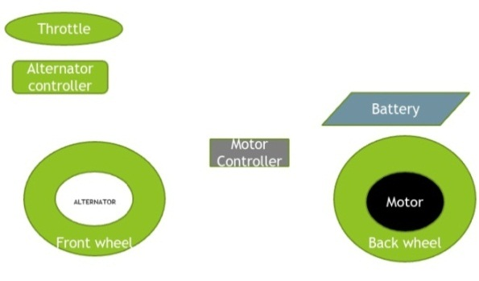

**Fig.1.1 ARCHITECTURE OF ELECTRIC VEHICLE**

* 1. **PARTS OF E-CYCLE:**
* BLDC Hub Motor
* Motor Controller
* Lithium ion Battery
* Braking system
* Throttle
* Horn with Headlights
* Pedal Assistance Sensor
* Alternator
* Controller for alternator
* Charging Module
  + 1. **MOTOR:**

There are a number of motors available for electric vehicle DC motors, Induction motor, DC brushless motor, Permanent magnetic synchronous motor and Switched reluctance motor. Here we use Hub type brushless dc motor. Hub motors are by far the most popular type. This is because the hub motors are already built into the hub, which makes mounting them to a wheel—either the front or the back, depending on preference—fairly simple. These motors typically feature three-phase wiring for power delivery and are DC brushless motors. This system's efficiency will be lower on slopes and during off-roading because it is not linked to the gears

* + 1. **CONTROLLER:**

Uncommon yet crucial, the motor controller is a component of the e-bike. The majority of people believe that the battery and the motor are in direct contact. However, that is untrue. The motor driver is linked to the battery before being connected to the motor. The motor driver has two primary responsibilities. In order for the motor to work, it first transforms the DC electricity from the battery into three-phase alternating current. The motor driver then uses the throttle input to continually alter the voltage between 0V and the maximum voltage provided by the battery, depending on the input from the user.

There are two difference of controller: Throttle-activated, pedal-activated. Pedal triggered controllers provide electricity when a pedal is depressed. The controller in such systems is mounted on the handlebar. The basic throttle mechanism is how throttle-based controls operate. Simply put, a throttle functions as a potentiometer. Throttle styles include thumb presses and twist grips.

* + 1. **LITHIUM ION BATTERY:**

A lithium-ion or Li-ion battery is a type of rechargeable battery which uses the reversible reduction of lithium ions to store energy. The anode (negative electrode) of a conventional lithium-ion cell is typically graphite made from carbon. The cathode (positive electrode) is typically a metal oxide. The electrolyte is typically a lithium salt in an organic solvent.

**1.4.4 BRAKING SYSTEM:**

The E-bike comes with an optional brake. When the brake is applied, the motor driver will turn off all of the power to the motors. The brakes fitted to an E-bike might also be used for another purpose. Regenerative braking is what it is known as. Lifting off the throttle causes the brakes to immediately apply to the motor, causing regenerative breaking, where the heat produced by the brakes is used to recharge the battery.

* + 1. **THROTTLE :**

The amount of power delivered to a motor at any one time is controlled by the throttle. The rider has control over the amount of power going to the motors through a throttle**.**

* + 1. **HORN AND LIGHT:**

This is an E-cycle Front light of 36V. Headlights must be in use when you cannot see at least 1000 feet in front of you. Headlights are required when weather is adverse, such as fog, rain, sleet, or snow. A bright headlight and a loud horn in one device , Separate push button to operate the horn , Both light and push button attach by stretch strap , Three headlight modes: high Lumens, medium Lumens, strobe , Water proof , Tail light also attaches with stretch strap Two tail light modes: On and strobe

* + 1. **PEDAL ASSISTANCE SENSOR:**

For pedal assist to work, there is a sensor that ‘talks’ to the motor so you can go your desired speed based on your pedal assist settings. There are two types of sensors, cadence, and torque, and both of them tell the cycle’s PAS (pedal assist system) when to engage the motor and propel the cycle forward.

* + 1. **ALTERNATOR:**

The Alternator is designed as three phase generator, which converts mechanical energy(rotational force) into electrical energy in the form of AC. It consist of Permanent Magnet Rotor and coil wound Stator. The Alternator is designed inside the hub and the hub is mounted on the front wheel of cycle.

* + 1. **CONTROLLER FOR ALTERNATOR:**

ALTERNATOR produces AC current where this circuit converts AC into DC and regulates the DC voltage according to the requirement and stores in to the battery

* + 1. **CHARGING MODULE:**

Charger, which converts alternating current (AC) from the electrical grid to direct current (DC) to charge the battery, allowing for faster charging. Timing is depending on the capacity of the battery and the charging rate of the charger. Different EV models have different charging requirements, and there are different types of chargers with varying charging rates. It is important for EV owners to ensure that their vehicle is compatible with a specific charger before attempting to use it.

***CHAPTER 2***

***PERFORMANCE AND ANALYSIS OF BLDC MOTOR***

**2.1 Introduction for PMBLDC MOTOR:**

Modern drive technology has grown significantly influenced by brushless DC motors, sometimes known as BLDC Motors. Due to their quick rise in popularity, a wider number of industries, including consumer electronics, the automotive industry, industrial automation, chemical and medical, and aerospace and instrumentation, are using them. Although brushed DC motors have dominated the sub-kilowatt market for a while now and have long been utilized for drives and power production, this market has always been ambiguous. However, the advancements in power electronics and microprocessor technology have made it possible for small Brushless DC Motors to flourish in terms of both performance and cost.

While a Brushless DC Motor and a Brushed DC Motor are similar, the latter uses brushes for commutation while the former uses electrical means. Conventional Brushed DC Motors use brushes that rotate in a constant magnetic field to send power to the rotor. A BLDC motor eliminates mechanically torn brushes by using electrical commutation, as was previously explained.

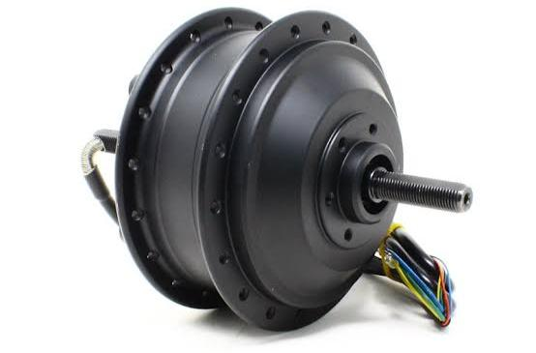

**FIG 2.1 HUB MOTOR**

A permanent magnet brushless direct current hub motor works based on the principle of **Lorentz Force**. The Lorentz force law which states that whenever a current carrying conductor placed in a magnetic field it experiences a force. As a consequence of reaction force, the magnet will experience an equal and opposite force.***Brushless DC motors (BLDC)*** have been a much focused area for numerous motor manufacturers as these motors are increasingly the preferred choice in many applications, especially in the field of motor control technology. BLDC motors are superior to brushed DC motors in many ways, such as ability to operate at high speeds, high efficiency, and better heat dissipation.

They are an indispensable part of modern drive technology, most commonly employed for actuating drives, machine tools, electric propulsion, robotics, computer peripherals and also for electrical power generation. With the development of sensorless technology besides digital control, these motors become so effective in terms of total system cost, size and reliability.

**2.2 Layout of PMBLDC Motor:**

**FIG2.2 PMBLDC MOTOR LAYOUT**

Stator(Windings)

Electronic Commutator instead of brushes for shaft position feedback.

Drive Electronics

**2.3 CONSTUCTION OF PMBLDC MOTOR:**

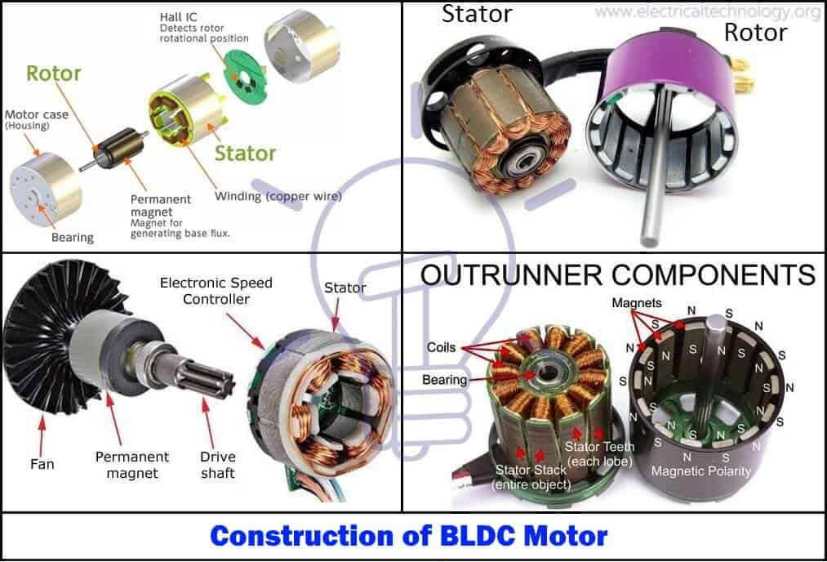

FIG 2.3 CONSTRUCTION OF BLDC MOTOR

BLDC motors can be built in a variety of physical arrangements. These can be set up as single-phase, two-phase, or three-phase motors depending on the stator windings. The most often used motors, though, are three-phase BLDC motors with permanent magnet rotors. This motor's design is very similar to both traditional DC motors and three-phase induction motors. Like all other motors, this one has a stator and a rotor. BLDC motor tator is constructed of stacked steel laminations to support the windings. These windings are inserted into slots that have been axially carved along the stator's inner perimeter. Either a star or a delta arrangement of these windings is possible. But the majority of BLDC motors have a three-phase stator with a star connection.

One or more coils are inserted into each slot to create each winding, which is made up of several interconnected coils. Each of these windings is dispersed around the stator's perimeter to provide an even number of poles.

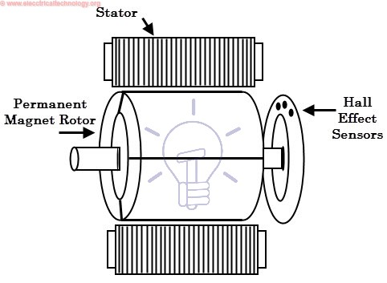

FIG2.4 BLDC MOTOR

**2.4 TYPES OF BLDC:**

Based on their structure or design, BLDC motors can be divided into two categories: (i) outer rotor design and (ii) inner rotor design. Note that the permanent magnets are always installed on the rotor and winding on the stator, irrespective of these types.

1) Inner rotor design (in runner): this is a conventional design, where the rotor is located at the core (center) and stator winding surrounds it.

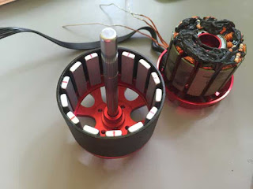

FIG 2.5 INNER ROTOR DESIGN OF BLDC MOTOR

2) Outer rotor design (outrunner): In this configuration, the rotor is external. i.e. stator windings are located at the core while the rotor, carrying permanent magnets, surrounds the stator.

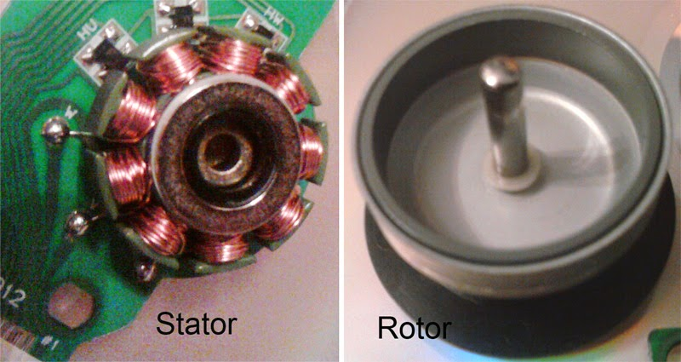

#### FIG 2.6 OUTER ROTOR DESIGN OF BLDC MOTOR

#### 2.5 SIMULATION:

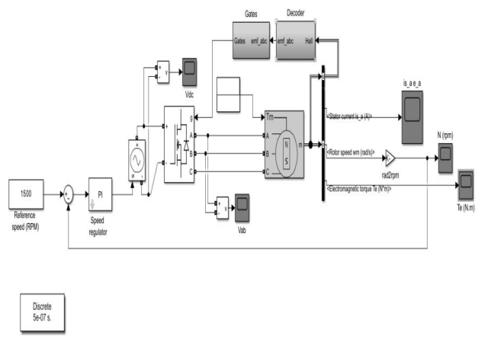

FIG 2.7 SIMULATION OF BLDC MOTOR

**At constant condition**

#### 

#### FIG 2.8 RESULT AT CONSTANT CONDITION

**At Variable Condition**

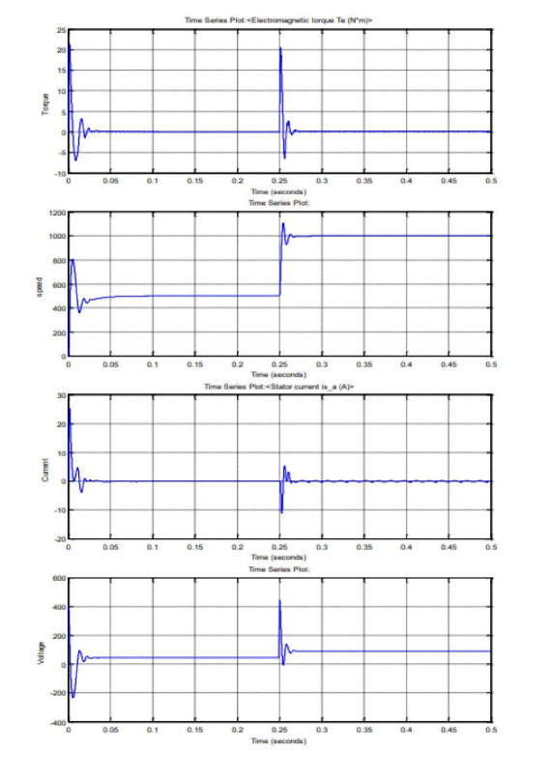

FIG 2.9 RESULT AT VARIABLE CONDITION

**2.6 POSITION SENSORS (HALL SENSORS)**

In a BLDC motor, the commutation is managed electronically because there are no brushes. The windings of the stator must be activated sequentially in order to turn the motor, and the location of the rotor's North and South poles must be known in order to precisely activate a specific set of stator windings. The position of the rotor is often detected and converted into an electrical signal using a position sensor, which is typically a hall sensor (which operates on the concept of the Hall Effect). The majority of BLDC motors sense the position of the rotor using three Hall Sensors that are incorporated into the stator.

Depending on whether the North or South pole of the rotor passes close to the Hall Sensor, the output will either be HIGH or LOW. It is possible to pinpoint the precise energising sequence by merging the data from the three sensors.

**2.7 WORKING PRINCIPLE OF PMBLDC MOTOR:**

BLDC motor works on the principle similar to that of a conventional DC motor, The Lorentz force law states that whenever a current-carrying conductor is placed in a magnetic field, it experiences a force. This is similar to how a standard DC motor operates. The magnet will feel a force that is equal to and opposite to the response force. The permanent magnet travels in a BLDC motor while the conductor that carries the current remains motionless.

The stator coils become electromagnets and begin to produce a consistent field in the air gap when they are electrically switched by a supply source. Despite the fact that the source of supply is DC, switching causes an AC voltage waveform with a trapezoidal shape to be produced. Rotor rotation is maintained by the interaction between the permanent magnet stator and electromagnet stator. Think about the illustration below, where the motor stator gets excited based on various switching states. The matching windings were energised as the North and South poles when the windings were switched between High and Low signals. The motor rotates when the North and South poles of the permanent magnet rotor line up with the poles of the stator.

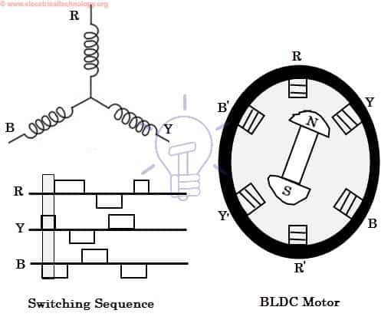

FIG 2.10 SWITCHING SEQUENCE OF BLDC MOTOR

Observe that when a motor is in a North-South or South-North alignment, attraction forces develop, and when they are in a North-North or South-South alignment, repulsion forces emerge. The motor turns clockwise in this manner.

**2.8 ADVANTAGES AND DISADVANTAGES OF PMBLDC MOTOR**

**2.8.1 Advantages :**

* It has no mechanical commutator and associated problems
* High efficiency due to the use of permanent magnet rotor
* High speed of operation even in loaded and unloaded conditions due to the absence of brushes that limits the speed
* Smaller motor geometry and lighter in weight than both brushed type DC and induction AC motors
* Long life as no inspection and maintenance is required for commutator system
* Higher dynamic response due to low inertia and carrying windings in the stator
* Less electromagnetic interference
* Quite operation (or low noise) due to absence of brushes

**2.8.2 DISADVANTAGES :**

* These motors are costly
* Electronic controller required control this motor is expensive
* Not much availability of many integrated electronic control solutions, especially for tiny BLDC motors
* Requires complex drive circuitry
* Need of additional sensors

**2.9 APPLICATIONS OF PMBLDC MOTORS:**

**Brushless DC Motors (BLDC)** **are used** for a wide variety of application requirements such as varying loads, constant loads and positioning applications in the fields of industrial control, automotive, aviation, automation systems, health care equipments, etc. Some specific applications of BLDC motors are

* Computer hard drives and DVD/CD players
* Electric vehicles, hybrid vehicles, and electric bicycles
* Industrial robots, CNC machine tools, and simple belt driven systems
* Washing machines, compressors and dryers
* Fans, pumps and blowers

**CHAPTER - 3**

**ANALYSIS OF MOTOR CONTROLLERS:**

**3.1 INTRODUCTION**

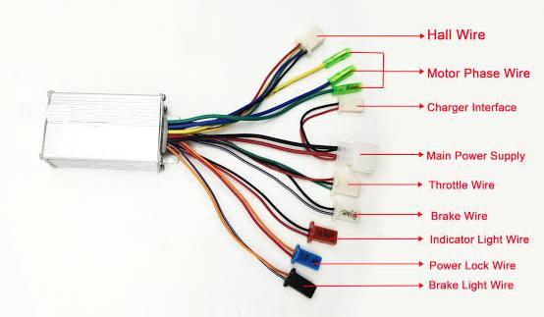

FIG 3.1 CONTROLLER

A motor controller is a device or group of devices that can coordinate in a predetermined manner the performance of an electric motor.[1] A motor controller might include a manual or automatic means for starting and stopping the motor, selecting forward or reverse rotation, selecting and regulating the speed, regulating or limiting the torque, and protecting against overloads and electrical faults. Motor controllers may use electromechanical switching, or may use power electronics devices to regulate the speed and direction of a motor.

The driving electronics are just as important as the stator and rotor in a BLDC motor if they are inherent to it. The next figure displays a block schematic of a typical Brushless DC Motor control or drive system.

**3.2 BLOCK DIAGRAM OF CONTROLLER:**

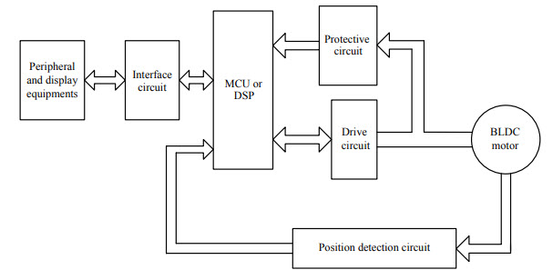

FIG 3.2 BLOCK DIAGRAM OF CONTROLLER

**3.3 ESC**

Electronic Speed Controller System, sometimes known as an ESC, is a common name for this driving circuitry. The Full Bridge Drive Circuit is a typical configuration. The system is made up of an MCU with PWM outputs, six MOSFETS for each of the three phases of the stator windings, feedback from the Hall sensors, and a few parts linked to the power supply.

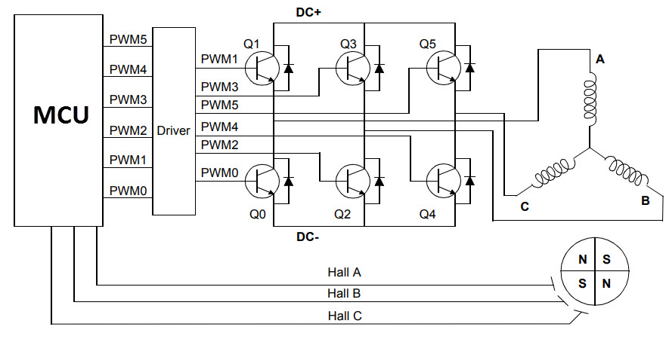

FIG 3.3 Block diagram of ESC:

Using the information from the Hall Sensors, the MCU may be programmed to switch the MOSFETS in the proper manner.

**3.4 TYPES OF MOTOR CONTROLLERS:**

* Motor Starters
* Reduced Voltage Starters
* Adjustable Speed Drives
* Intelligent Drives

**3.5 APPLICATIONS OF MOTOR CONTROLLERS:**

Motor controllers are used with both direct current and alternating current motors. A controller includes means to connect the motor to the electrical power supply, and may also include overload protection for the motor, and over-current protection for the motor and wiring. A motor controller may also supervise the motor's field circuit, or detect conditions such as low supply voltage, incorrect polarity or incorrect phase sequence, or high motor temperature. Some motor controllers limit the inrush starting current, allowing the motor to accelerate itself and connected mechanical load more slowly than a direct connection. Motor controllers may be manual, requiring an operator to sequence a starting switch through steps to accelerate the load, or may be fully automatic, using internal timers or current sensors to accelerate the motor.

Some types of motor controllers also allow adjustment of the speed of the electric motor. For direct-current motors, the controller may adjust the voltage applied to the motor, or adjust the current flowing in the motor's field winding. Alternating current motors may have little or no speed response to adjusting terminal voltage, so controllers for alternating current instead adjust rotor circuit resistance (for wound rotor motors) or change the frequency of the AC applied to the motor for speed control using power electronic devices or electromechanical frequency changers.

The physical design and packaging of motor controllers is about as varied as that of electric motors themselves. A wall-mounted toggle switch with suitable ratings may be all that is needed for a household ventilation fan. Power tools and household appliances may have a trigger switch that only turns the motor on and off. Industrial motors may be more complex controllers connected to automation systems; a factory may have a large number of motor controllers grouped in a [motor control center](https://en.wikipedia.org/wiki/Motor_control_center). Controllers for electric travelling cranes or electric vehicles may be mounted on the mobile equipment. The largest motor controllers are used with the pumping motors of [pumped storage](https://en.wikipedia.org/wiki/Pumped_storage) hydroelectric plants, and may carry ratings of tens of thousands of horsepower (kilowatts).

**CHAPTER - 4**

**DESIGN ANALYSIS OF BATTERY PACKAGE**

* 1. **INTRODUCTION:**

A battery is an electrochemical device which store power in the form of chemical energy. It works on to chemical reactions in which electrons flow through circuit when the external circuit is connected to the anode and cathode. Battery is used for to provide the power to motor to all application. Lithium phosphate type cell used in the battery. Major advantage of lithium cell is non explosive. Battery is used where we can store energy is required to be stored for future purposes. Emergency purpose batteries for backup. A portable device has a battery to use anywhere you want. An emergency device like an inverter, torch are used when there is no power. Low power devices like watches, ox meter and all other applications The mains supply is not appropriate for all situations. Itwill depend upon the devices requirement like how much power is needed or what device.

* 1. **TYPES OF BATTERY:**
* Lead-Acid Batteries
* Lithium-Ion Batteries
* Nickel-Metal Hydride Batteries
* Ultracapacitor
  1. **LITHIUM - ION BATTERY:**

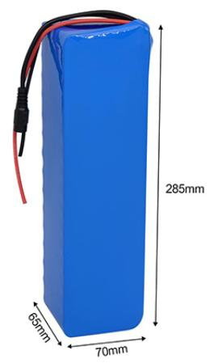

FIG 4.1 LITHIUM ION BATTERY

A lithium-ion or Li-ion battery is a type of rechargeable battery which uses the reversible reduction of lithium ions to store energy. The anode (negative electrode) of a conventional lithium-ion cell is typically graphite made from carbon. The cathode (positive electrode) is typically a metal oxide. The electrolyte is typically a lithium salt in an organic solvent. Generally, the negative electrode of a conventional lithium-ion cell is graphite made from carbon. The positive electrode is typically a metal oxide. The electrolyte is a lithium salt in an organic solvent. The anode (negative electrode) and cathode (positive electrode) are prevented from shorting by a separator. The anode and cathode are separated from external electronics with a piece of metal called a current collector. The electrochemical roles of the electrodes reverse between anode and cathode, depending on the direction of current flow through the cell.

The most common commercially used anode is graphite, which in its fully lithiated state of LiC6 correlates to a maximal capacity of 1339 C/g (372 mAh/g). The cathode is generally one of three materials: a layered oxide (such as lithium cobalt oxide), a polyanion (such as lithium iron phosphate) or a spinel (such as lithium manganese oxide). More experimental materials include graphene-containing electrodes, although these remain far from commercially viable due to their high cost.

* 1. **WORKING OF LITHIUM – ION BATTERY**

The rechargeable[lithium-ion battery](https://robu.in/product-category/batteries/li-ion/) is made of one or more power-generating compartments called cells. Each cell has essentially three components.- positive electrode, negative electrode and electrolyte. A **positive electrode** connects to the battery's positive or + terminal. A**negative electrode** connects to the negative or − terminal. And a chemical called an **electrolyte** in between them. The positive electrode is typically made from a chemical compound called [lithium-cobalt oxide (LiCoO2)](https://en.wikipedia.org/wiki/Lithium_cobalt_oxide) or[lithium iron phosphate (LiFePO4)](https://robu.in/product-category/batteries/lifepo4-battery/). The negative electrode is generally made from carbon (graphite). The electrolyte varies from one type of battery to another.

The electrolyte carries positively charged lithium ions from the anode to the cathode. The movement of the lithium ions creates free electrons in the anode which creates a charge at the positive current collector.  The electrical current then flows from the current collector through a device being powered (cell phone, computer, etc.) to the negative current collector. The separator blocks the flow of electrons inside the battery.

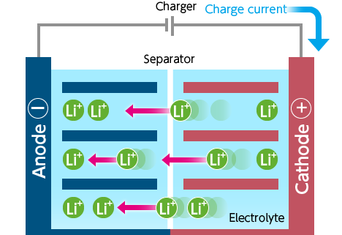

FIG 4.2 CHARGING OF LITHIUM - ION CELL

While the battery is discharging and providing an electric current, the anode releases lithium ions to the cathode, generating a flow of electrons from one side to the other. When plugging in the device, the opposite reaction happens, the cathode releases lithium ions and anode receives them. This is how the Lithium-ion battery works.

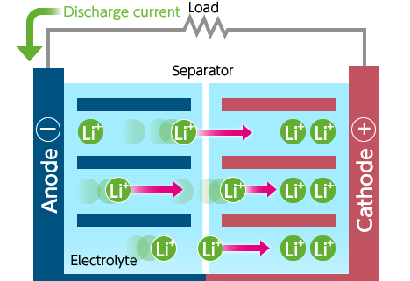

FIG 4.3 DISCHARGING OF LITHIUM - ION CELL

In this battery, the energy density and power density are most common things of the battery. Generally, the energy density measures in watt-hours per kilogram (wh/kg) and is the amount of energy the battery can store with respect to its mass. Power density measures in watts per kilogram (W/kg) and is the amount of power of battery with respect to its mass.

* 1. **CHARGING AND DISCHARGING**

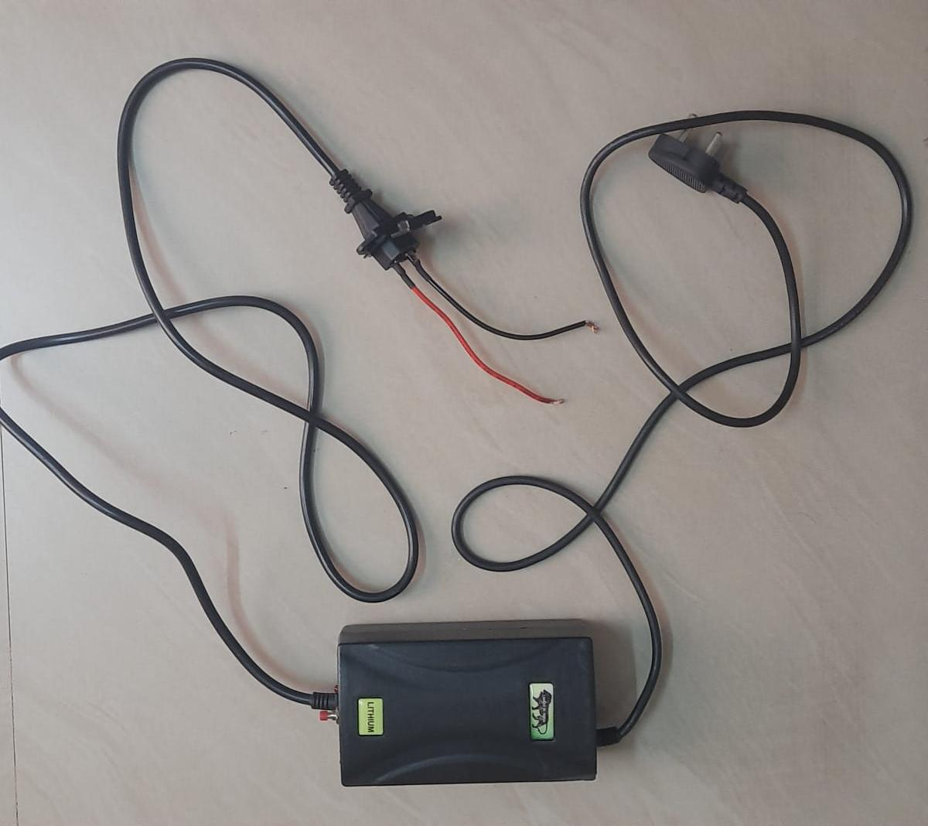

FIG 4.4 Li – ion Charger

During discharge, lithium ions (Li+) carry the [current](https://en.wikipedia.org/wiki/Electrical_current) within the battery cell from the negative to the positive electrode, through the non-[aqueous](https://en.wikipedia.org/wiki/Aqueous_solution) [electrolyte](https://en.wikipedia.org/wiki/Electrolyte) and separator diaphragm.

During charging, an external electrical power source (the charging circuit) applies an over-voltage (a higher voltage than the battery produces, of the same polarity), forcing a charging current to flow **within each cell** from the positive to the negative electrode, i.e., in the reverse direction of a discharge current under normal conditions. The lithium ions then migrate from the positive to the negative electrode, where they become embedded in the porous electrode material in a process known as [**intercalation**](https://en.wikipedia.org/wiki/Intercalation_(chemistry))**.**

Energy losses arising from electrical [contact resistance](https://en.wikipedia.org/wiki/Contact_resistance) at interfaces between [electrode](https://en.wikipedia.org/wiki/Electrode) layers and at contacts with current collectors can be as high as 20% of the entire energy flow of batteries under typical operating conditions.

The charging procedures for single Li-ion cells, and complete Li-ion batteries, are slightly different:

* A single Li-ion cell is charged in two stages:

1. [Constant current](https://en.wikipedia.org/wiki/Constant_current) (CC)
2. [Constant voltage](https://en.wikipedia.org/wiki/Voltage_source) (CV)

* A Li-ion battery (a set of Li-ion cells in series) is charged in three stages:

1. [Constant current](https://en.wikipedia.org/wiki/Constant_current)
2. Balance (only required when cell groups become unbalanced during use)
3. [Constant voltage](https://en.wikipedia.org/wiki/Voltage_source)

## ADVANTAGES OF LITHIUM-ION BATTERY

Now a days Lithium-ion batteries are popular because they have a number of important advantages over competing technologies:

* Generally, they are much lighter than other types of rechargeable batteries of the same size.
* They hold their charge. A lithium-ion battery pack loses only about 5 percent of its charge per month.
* High specific energy and high load capabilities with Power Cells
* Long cycle and extend shelf-life; maintenance-free.  They can handle hundreds of charge/discharge cycles.
* High capacity, low internal resistance, good coulombic efficiency
* Simple charge algorithm and reasonably short charge times
* Low self-discharge (less than half that of NiCd and NiMH)

## 4.7 LIMITATIONS OF LITHIUM-ION BATTERY

* Requires protection circuit to prevent thermal runaway if stressed
* Degrades at high temperature and when stored at high voltage
* No rapid charge possible at freezing temperatures (<0°C, <32°F)
* Transportation regulations required when shipping in larger quantities
* They are extremely sensitive to high temperatures. Heat causes lithium-ion battery packs to degrade much faster than they normally would.

## APPLICATIONS OF LITHIUM-ION BATTERY

Lithium batteries have a long list of real-world applications beyond running the apps on your phone. From life-saving medical equipment to luxury yachts, lithium batteries keep both the essentials and the comforts of modern life running with safety and reliability.

**CHAPTER – 5**

**ANALYSIS OF BATTERY MANAGEMENT SYSTEM (BMS)**

**5.1 INTRODUCTION**

Battery management system (BMS) is technology dedicated to the oversight of a battery pack, which is an assembly of battery cells, electrically organized in a row x column matrix configuration to enable delivery of targeted range of voltage and current for a duration of time against expected load scenarios.

The oversight that a BMS provides usually includes:

* Monitoring the battery
* Providing battery protection
* Estimating the battery’s operational state
* Continually optimizing battery performance
* Reporting operational status to external devices

**5.2 Types of BMS**

* Centralized BMS,
* distributed BMS
* Modular BMS

## 5.3 WORKING OF BATTERY MANAGEMENT SYSTEMS

Battery management systems do not have a fixed or unique set of criteria that must be adopted. The technology design scope and implemented features generally correlate with:

* The costs, complexity, and size of the battery pack
* Application of the battery and any safety, lifespan, and warranty concerns
* Certification requirements from various government regulations where costs and penalties are paramount if inadequate functional safety measures are in place

There are many BMS design features, with battery pack protection management and capacity management being two essential features. We’ll discuss how these two features work here. Battery pack protection management has two key arenas: electrical protection, which implies not allowing the battery to be damaged via usage outside its SOA, and thermal protection, which involves passive and/or active temperature control to maintain or bring the pack into its SOA.

**5.4 ADVANTAGES AND DISADVASNTAGES OF BMS**

**5.4.1 ADVANTAGES:**

Advantages of BMS include substantial savings on air conditioning and heating costs. Your building's HVAC system can work on a management schedule for specific days, and specific times. Heating, ventilation and air-conditioning costs can be reduced by having these systems timed and scheduled properly.

**5.4.2 DISADVANTAGES**

The issue is that there will be large blind spots because most building management systems do not control smaller equipment. Because the cost to install, maintain, and utilize is so high, most properties with a BMS only have it installed on the major loads, such as large HVAC equipment and lighting.

**CHAPTER 6**

**PEDAL ASSISTANCE SENSOR**

**6.1 INTRODUCTION:**

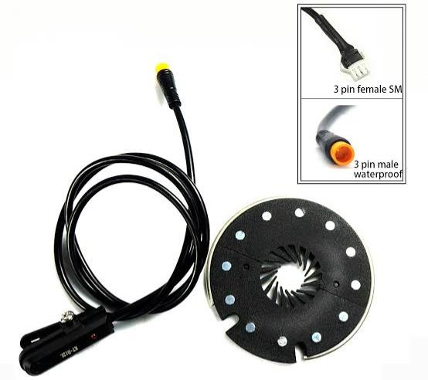

FIG 6.1 PEDAL ASSISTANCE SENSOR

For pedal assist to work, there is a sensor that ‘talks’ to the bike’s motor so you can go your desired speed based on your pedal assist settings. There are two types of sensors, cadence, and torque, and both of them tell the bike’s PAS (pedal assist system) when to engage the motor and propel the bike forward.

For pedal assist to work, there is a sensor that ‘talks’ to the bike’s motor so you can go your desired speed based on your pedal assist settings. There are two types of sensors, cadence, and torque, and both of them tell the bike’s PAS (pedal assist system) when to engage the motor and propel the bike forward. Simply put, all pedal assist does is makes things easier. The additional power provided by pedal assistance reduces the amount of energy the rider needs put into pedaling themself. That means riders are able to ride further, ride faster, and handle difficult terrain, like hills, more easily.

It also means that people don’t need to be exceptionally fit to ride either. A person with average fitness riding an electric bike can ride up a hill just as quickly as someone with above-average fitness [using a regular bike](https://www.linkyinnovation.com/electric-bikes-vs-regular-bikes/), if not more quickly.

**6.2 TYPES OF PEDAL ASSISTANCE SENSOR**

There are two main types of pedal assist systems (PAS):

* Torque Sensing
* Cadence Sensing.

Both of them send a signal to the bike's motor to power up pedal assist in response to the actions of the rider, but differ in when and how pedal assist is activated.

**6.3 WORKING OF PEDAL ASSISTANCE SENSOR:**

As mentioned before, pedal assist only works when the rider is actively turning the pedals themselves. When they are not pedaling, the bike will not accelerate or maintain speed on its own, unless it also has a throttle and the rider is using that too.

When you start pedaling, you will often feel the pedal assist quite literally kick in. Depending on the level of assistance and type of sensors used, the act of pedaling will feel much easier as soon as you start doing it. Sometimes, it can feel like the bike is “pushing” you (in a certain sense), but remember it’s not actually propelling you – it’s just making pedaling that much easier.

Most pedal assist systems come with different, selectable levels of assistance. The higher the assistance level you choose, the easier pedaling becomes. Five levels is the most common amount, although bikes with as few as three and as much as seven are not unheard of. As mentioned before, pedal assist only works when the rider is actively turning the pedals themselves. When they are not pedaling, the bike will not accelerate or maintain speed on its own, unless it also has a throttle and the rider is using that too.

When you start pedaling, you will often feel the pedal assist quite literally kick in. Depending on the level of assistance and type of sensors used, the act of pedaling will feel much easier as soon as you start doing it. Sometimes, it can feel like the bike is “pushing” you (in a certain sense), but remember it’s not actually propelling you – it’s just making pedaling that much easier.

Most pedal assist systems come with different, selectable levels of assistance. The higher the assistance level you choose, the easier pedaling becomes. Five levels is the most common amount, although bikes with as few as three and as much as seven are not unheard of.

**6.4 ADVANTAGES:**

These sensors only supply power to the pedals if they detect active physical input from the user. Not only do torque sensors provide riders with more overall control, but they also ensure the rider doesn't slack off and enjoy a free ride.

# CHAPTER 7

# ANALYSIS OF ALTERNATOR

# 7.1 INTRODUCTION:

An alternator is defined as a machine or generator which produces AC (Alternating Current) supply and it converts mechanical energy into electrical energy, so it is also called an AC generator or synchronous generator. There are different types of alternators based on applications and design. The Marine type alternator, Automotive type alternator, Diesel-electric locomotive types alternator, Brushless type alternator, and Radio alternators are the types of alternators based on the applications. The Salient Pole type and Cylindrical [rotor](https://www.elprocus.com/induction-motor-types-advantages/)type are the types of alternators based on the design.

# 

# FIG 7.1 HUB TYPE ALTERNATOR

# 

### 

### 7.2 CONSTRUCTION OF AN ALTERNATOR

The main components of an alternator or synchronous generator are rotor and stator. The main difference between rotor and stator is, the rotor is a rotating part and stator is not a rotating component means it is a stationary part. The motors are generally run by rotor and stator. The Alternator is designed as three phase generator. It consist of permanent Magnet rotor and coil wounded stator. The Alternator is designed inside the hub and the hub is mounted on the front wheel.

**7.3 WORKING:**

The **working principle of an alternator** is very simple. It is just like the [basic principle of DC generator](https://www.electrical4u.com/principle-of-dc-generator/). It also depends upon [Faraday’s law of electromagnetic induction](https://www.electrical4u.com/faraday-law-of-electromagnetic-induction/) which says the [current](https://www.electrical4u.com/electric-current-and-theory-of-electricity/) is induced in the conductor inside a [magnetic field](https://www.electrical4u.com/magnetic-field/) when there is a relative motion between that [conductor](https://www.electrical4u.com/electrical-conductor/) and the magnetic field.

Similarly in this electric cycle, the alternator is mounted on the front wheel.whenever the rear wheel starts to rotate, then front wheel also rotate automatically. Which in turn rotate the rotor and the mechanical energy (rotational motion) is converted into electrical energy by the principle of electromagnetic induction.

### 7.4 CHARACTERISTICS:

The characteristics of an alternator are

1. **Output Current with Speed of Alternator:** The output of the current reduced or decreased when the alternator speed reduced or decreased.
2. **The efficiency with Speed of Alternator:** Efficiency of an alternator is reduced when the alternator runs with low speed.
3. **Current Drop with Increasing Alternator Temperature:** When the temperature of an alternator increased the output current will be reduced or decreased.

### ****7.5 APPLICATIONS****

* Automobiles
* Electrical power generator plants
* Marine applications
* Diesel electrical multiple units
* Radiofrequency transmission

### ****7.6 ADVANTAGES****

* Cheap
* Low weight
* Low maintenance
* Construction is simple
* Robust
* More compact

### ****7.7 DISADVANTAGES****

* Alternators need converter to get dc.
* Alternators will overheat if the current is high

**7.8 ANALYSIS OF ALTERNATOR CONTROLLER:**

The Alternator controller unit is an electronic module that interfaces between the alternator and the battery to control the generated voltage & current and to regulate the voltage according to the rating of the battery. This controller circuit also help to limit the generated power from alternator, inturn reduces the risk of generative braking. Because if more load is connected to alternator, then it act at generative braking system.

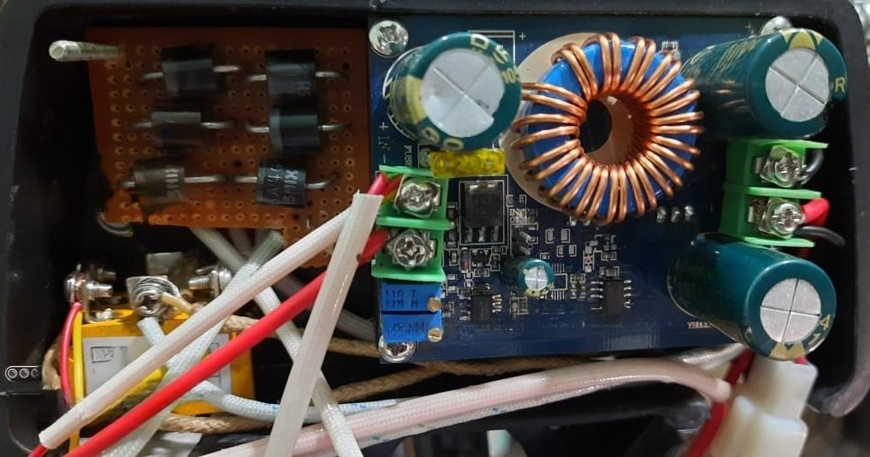

FIG 7.2 CONTROLLER CIRCUIT FOR ALTERNATOR

This controller circuit consist of

* Rectifying Unit,
* Converter Unit
* Regulator Unit

**7.8.1 RECTIFYING UNIT:**

It consist of three phase rectifier which converts three phase alternating current into direct current

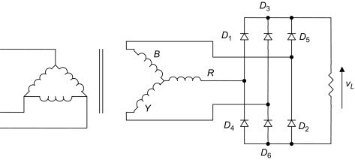

FIG 7.3 THREE PHASE RECTIFIRE

**7.8.2 CONVERTER UNIT :**

The output of the rectifier is fed into the converter circuit. The converter circuit converts variable DC into Fixed DC. Also the converter circuit plays a major role in the limitation of load connected to the alternator. It control the load current consumed from the alternator, thereby reduces the load.

**7.8.3 REGULATOR UNIT**

The output voltage of converter is regulated and fed to battery according to the requirement of the Battery’s charging voltage.

**CHAPTER 8**

**ADDITIONAL FEATURES IN**

**“ BIJLI – THE E CYCLE”**

# 8.1 ELECTRICAL CUM MECHANICAL BRAKE:

# 

# FIG 8.1 ELECTRICAL CUM MECHANICAL BRAKE

Electro-Mechanical Brake (EMB) is the brake system that is actuated by electrical energy and has a similar design with the Electric Parking Brake (EPB). It uses motor power and gears to provide the necessary torque and a screw & nut mechanism is used to convert the rotational movement into a translational one. The main difference of EMB compared with EPB is that the functional requirements of components are much higher to provide the necessary performance for service braking such as response time. Such highly responsive and independent brake actuators at each wheel lead to enhanced controllability which should result in not only better basic braking performance, but also improvements in various active braking functions such as integrated chassis control, driver assistance systems, or cooperative regenerative braking. Although the EMB system has the potential for numerous advantages and innovations in braking, it has yet to be successfully introduced in series production mainly due to safety and cost concerns. Recent studies have been made to investigate the functional safety aspects and additional mechanical backup measures in this regard.

Although the EMB is conventionally thought of as a solution for oil-free braking system, the EMB system introduced in the current paper includes a hydraulic piston to make several functions possible. First, the hydraulic system allows for a mechanical back-up mechanism that leads to increased reliability. Second, the clamping force for braking control can be measured with a pressure sensor. And finally, the dual piston structure proposed in the current paper, which leads to amplification of the force transmission, allows for the design of lower specification and higher cost effective motor and gear components.

**8.2 THROTTLE WITH DISPLAY:**



FIG 8.2 THROTTLE WITH BATTERY LEVEL INDICATOR

* This thumb throttle has a display suitable for use with lithium batteries from 12 volt to 42 volts as well as on/off switch which you can use as a Power , Lamp ,Throttle on/off or other uses. The amount of power delivered to a motor at any one time is controlled by the throttle. The rider has control over the amount of power going to the motors through a throttle**.**

**8.3 HORN ATTACHED WITH LIGHT:**

|  |  |
| --- | --- |
|  |  |

FIG 8.3 HORN ATTACHED WITH LIGHT:

This is an E-Bike Front light of 36V. Headlights must be in use when you cannot see at least 1000 feet in front of you. Headlights are required when weather is adverse, such as fog, rain, sleet, or snow

A bright headlight and a loud horn in one device , Separate push button to operate the horn , Both light and push button attach by stretch strap , Three headlight modes: high Lumens, medium Lumens, strobe , Water proof , Tail light also attaches with stretch strap Two tail light modes: On and strobe.

**8.4 DISPLAY:**

1

2

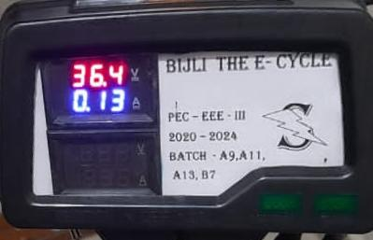

FIG 8.4 DISPLAY

**1=>** Display’s the voltage and current fed to the battery from the

alternator in terms of volt and amps.

**2=>** Display’s the Battery’s voltage and load current

Separate switches are used for controlling power ON/OFF of motor circuit and Turn ON/OFF of alternator circuit.

**CHAPTER 9**

**OUTCOMES AND RESULT OF**

**“ BIJLI E-CYCLE ”**

**9.1 SYSTEM OUTPUT**

**1. POWER SOURCE:**

A battery that stores electrical energy, often constructed of lithium ion, powers the E-CYCLE. This lithium-ion battery is rated at 36V, 12AH. This battery has a 30km range and can survive up to 2000 charging and discharge cycles.

* 1. **MOTOR:**

The motor is a PMBLDC hub type. 350W, 36V hub motor is what it is. It is immediately attached to the back wheel using this framework. The car can travel at a speed of up to 36 km/h.

* 1. **CONTROLLER:**

To produce a revolving magnetic field, the motor controller delivers a series of signals to the motor's windings. By altering the frequency and amplitude of these signals, the motor's speed and torque may be managed.

* 1. **THROTTLE:**

In addition to an on/off switch that may be used for power, a lamp, the throttle, or other purposes, this thumb throttle incorporates a display that is compatible with lithium batteries ranging in voltage from 12 volts to 42 volts. The throttle regulates the amount of power that is sent to a motor at any one time. Through a throttle, the rider may modify the amount of power supplied to the motors.

* 1. **ALTERNATOR:**

The front wheel begins to revolve as soon as the motor begins to move the vehicle. The front-wheel-mounted alternator will transform mechanical energy (rotational energy) into electrical energy..

* 1. **CONTROLLER FOR ALTERNATOR:**

The controller adjusts the output voltage before feeding it into the battery and changes the produced ac to dc.

* 1. **ELECTRICAL CUM MECHANICAL BREAK:**

The electrical break interrupts the motor power supply when the break is applied, which thus The wheel is stopped by the mechanical brake.

* 1. **DISPLAY:**

It displays the voltage of the battery, the load current, the produced voltage, and the current used for charging.

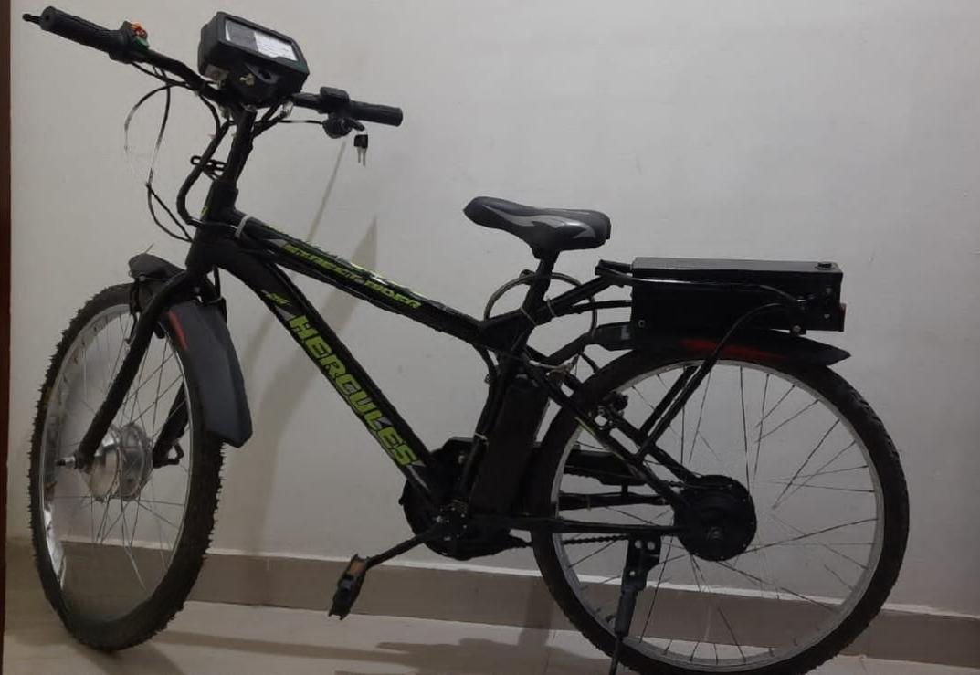

FIG 9.1 “ BIJLI ---- E-CYCLE”

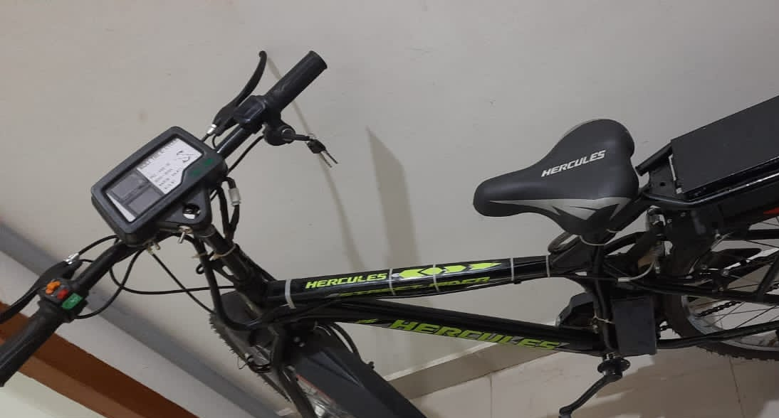

FIG 9.2 TOP VIEW OF E-CYCLE

**9.2 LIMITATIONS:**

* **LIMITED RANGE**: Compared to gasoline-powered cars, EVs have a shorter range, and variables like weather, driving technique, and topography can further restrict this range.
* **CHARGING INFRASTRUCTURE:** The lack of charging outlets, particularly in rural and isolated places, might make EV adoption difficult.
* **BATTERY PRODUCTION AND DISPOSAL:** Batteries for EVs are produced and disposed of in ways that may have an adverse effect on the environment, including resource depletion and pollution.
* **COST:** Although this cost is anticipated to drop as manufacturing rises and technology advances, EVs are often more expensive than conventional automobiles.
* **PERFORMANCE:** Especially in terms of acceleration and highest speed, EVs may not perform as well as gasoline-powered vehicles.

**9.3 FUTURE SCOPES**

* **CHARGING INFRASTRUCTURE**: EVs may become more suitable for long-distance travel with the development of charging infrastructure, including the use of fast-charging stations and wireless charging technologies.
* **RENEWABLE ENERGY**: A more sustainable and clean source of energy to charge EVs may become available with the expansion of renewable energy sources like wind and solar power.
* **MOTOR:** PMDC motors don't need field windings, hence they don't have copper loss in the field circuit. Compared to traditional DC motors, PMDC motors are more efficient. Due to reduced torque repulsion, PMSM generates 94 percent more smooth torque than BLDC while also being more efficient and quieter. Because PMSM has a better power density, it will enable motor size reduction.

**CONCLUSION:**

Finally, because of their enhanced performance, lower running costs, and favourable environmental effects, electric vehicles (EVs) are growing in popularity. The driving range of EVs is expanding as battery technology advances, making them an attractive alternative for many motorists. The electric cycle is a cutting-edge form of transportation that provides us with an easy and practical route of transportation for people of all ages. It is one of these transit routes. The motor in this cycle is highly efficient, and the battery bank is light and rapid. The electric cycle's ability to produce electricity from waste energy while saving hundreds of millions of dollars in foreign currencies is its most important feature. The fact that it doesn't pollute the environment, is environmentally friendly, and runs quietly is the second most significant aspect.

Additionally, the hassle of charging an EV is decreasing as more charging infrastructure is put in place. However, many buyers continue to be discouraged by EVs' greater initial cost when compared to conventional gas-powered automobiles. Despite this, some people may find that purchasing an EV is a financially sound decision because to the long-term fuel and maintenance cost benefits. Overall, the move to electric vehicles is a positive trend in the fight against climate change and the reduction of greenhouse gas emissions. Given that they emit no emissions at the tailpipe and may be fuelled by renewable energy sources, electric cars are a potential way to cut greenhouse gas emissions and combat climate change. Despite the higher upfront cost of electric vehicles, they offer long-term savings on fuel and maintenance costs, making them a financially sensible choice for some consumers.

As battery technology advances, electric car driving range expands, and more charging stations are installed, making them a more practical alternative for drivers. Government incentives, market demand, and technology developments are accelerating the use of electric cars. With rapid torque and silent operation, electric vehicles provide a better driving experience than conventional gas-powered vehicles, making them a desirable alternative for drivers who value performance. 96 For many customers, the high initial cost of electric vehicles remains a deterrent, but for some, the long-term fuel and maintenance cost reductions may make them a financially sound decision.

Electric cars provide tremendous environmental advantages, but there are issues that need to be resolved with the manufacture and disposal of batteries. We can lessen our reliance on foreign oil and improve our energy security by using electric cars. Autonomous electric vehicle development has the potential to transform how we see transportation, making it safer, more effective, and more sustainable. Continuous research and development is necessary for electric cars, a quickly developing technology, to continue to advance and be used by more people.

**REFERENCE**

1. Manas Rajan Panda, Vivek Ranjan, Prammod Lakra (2017, April). Electric Bicycle. ISSN: 2455-2631 .

2. Lorenzo Stilo, Diana Segura-Velandia, Heinz Lugo, Paul P.Conway, Andrew A.West(2021, October). Electric Bicycle,Next Generatiojn Low Carbon Transport System:A Survey. Tr5ansportatiojn Research Interdisciplinary Perspectives, 100347.

3. British Standards Institution,2017.EN 15194:2017:Cycles-Electrically Power Assisted Cycles-Epac Bicycles, Brussels:Cen.

4. Chlebosz, W., Ombach, G., Junak, J., 2010. Comparison Of Permanent Magnet Brushless Motor With Outer And Inner Rotor Used In E-Bike. Rome, Italy, s.n.

5.Ranjan Kumar, Munna Kumar, Pradyumn Sah, Mustaim Alam, Dr. M. Ashok Raj Kumar (2018). Design And Fabrication Of Electric Bicycle. IJERT. ISSN:2278-0181.

6. "The Future of Electric Vehicles in the United States: Challenges and Opportunities." National Renewable Energy Laboratory, 2020.

7. "Electric Vehicle Battery Technologies: State-of-the-Art and Challenges." Journal of Power Sources, 2020

8. K.W.E CHENG, et.al., This paper provides an overview of the “Recent work of electric vehicle “in the region. The paper describes the development and the comparison of different part of components.

9. Mohamed M,et.al., has proposed a paper on “ Study of electric vehicles in India opportunities and challenges” Battery Electric Vehicles are complete electric vehicles that are powered by only electricity and do not include a petrol/diesel engine, fuel storage or exhaust pipe.

10. "Consumer Adoption of Electric Vehicles: A Literature Review." Transportation Research Part D: Transport and Environment, 2020.